Form LRA 67 | (r. 80(1))

REPUBLIC OF KENYA

THE LAND REGISTRATION ACT

THE LAND REGISTRATION (GENERAL) REGULATIONS, 2017

Date Received |  | Presentation Book |  | Official Fees Paid
………………… |  | No…………………. |  | Kshs.
 |  |  | CAUTION
 |  | TITLE NUMBER:...............................................
 | Date of Caution |  | 08/08/2024
 | The Cautioner: |  | ZAKAYO RUTO of P.O Box 1234, Nairobi (hereinafter called the “Cautioner” which expression shall, where the context so requires, include his personal representatives and assigns)
 | ID/Passport No. |  | 45454545
 | Registration No of the
 | Cautioner (if any)
 | Address of the |  | P.O Box No 4646
 | Cautioner (within
 | Kenya for service of
 | Notice).
 | The Proprietor: |  | BABA YAO of P.O Box 256, NAIROBI, (hereinafter called the “Proprietor” which expression shall, where the context so requires, include his personal representatives and assigns)
 | ID/Passport |  | 35637666
 | Registration No. of the
 | Proprietor (if any)
 | PIN Number. |  | A847889403E
 | Citizenship/Place of |  | KENYAN
 | registration.
 | Address of the |  | P.O Box 37373
 | Proprietor (within
 | Kenya for service of
 | notice).
 | Interest Claimed |  | PURCHASER’S INTEREST
 | Extent or Scope of the |  | Register caution restraining BABA YAO in person, through  any of their agents, servants or any other manner  howsoever and whatsoever from wasting, damaging,  alienating, selling, transferring, leasing and/or interfering  with SYOKIMAU/SYOKIMAU BLOCK 2/3737 until the  dispute between the purchaser and vendor in the  agreement dated is resolved since the sum of Kshs.  800,000/= has already been paid to the proprietor.
 | Caution
 | (Absolutely/Subject to
 | the Interest of | the
 | Cautioner)

- The Cautioner HEREBY APPLIES for registration of a Caution over the above Title to the extent or scope stated above.

- The Cautioner forbid the registration of dealings and the making of entries in the register relating to the Title to the extent or scope of the Caution without the Cautioner’s consent until this Caution has been withdrawn by the Cautioner or removed by order of the Court or the Registrar.

- The Cautioner hereby attaches the following documents is support of the application*:-
  - Copy of sale agreement
  - Receipts to prove payment of purchase price

IN WITNESS the Cautioner has signed this Caution.

EXECUTION:

SIGNED by the Cautioner in
the presence of:-

ZAKAYO RUTO

Coloured
Photograph

ID/No…45454545……….…………..
PIN No………….38453659………….
Signature……ZR……….……..

Certificate of Verification

- CERTIFY that the above-named ………ZAKAYO RUTO..…………..

appeared before me on the …8th……... day of ……August.……. 20…24… and being known to me/being identified by*……………………………… of

………………………… acknowledge the above signatures or marks to be his/hers and that he/she had freely and voluntarily executed this instrument and understood its contents.

…………..GKM……………………..
Signature and Designation of
Person Certifying**

REGISTERED and SEALED this …12th … day of …AUGUST………………. 2024……

seal…………………………………………………..

LAND REGISTRAR

Name: KEITH MOKAYA

Signature: 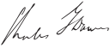

STATUTORY DECLARATION

I ZAKAYO RUTO (in support of this caution) do hereby sincerely declare as follows:-

- THAT I am the applicant here thus competent to make this declaration.
- THAT I entered into an Agreement of sale with BABA YAO for the whole of the property herein for a consideration of Kenya Shillings Eight Hundred Thousand (Kshs. 800,000/=).
- THAT the whole of the purchase price has been paid to the vendor.
- THAT I have also taken vacant possession of the property and I am currently in occupation thereof.
- THAT the vendor is in the process of attempting to transfer the property to a third party, JANET MULI.
- THAT I am applying for this caution to prevent any transfer of the property until the issue of ownership is resolved.
- THAT I make this declaration conscientiously believing the same to be true and according to the Oaths and Statutory Declarations Act.

I make this declaration conscientiously believing the same to be true and according to the Oaths and Statutory Declaration Act.

DECLARED before me at
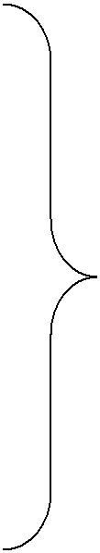
………KIATU KIVIKU…………………………

on the …………12TH………………….day
of……AUGUST………………………2024…

……………….……………..

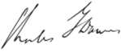
……………………………………………..
Signature of Advocate or Land Registrar

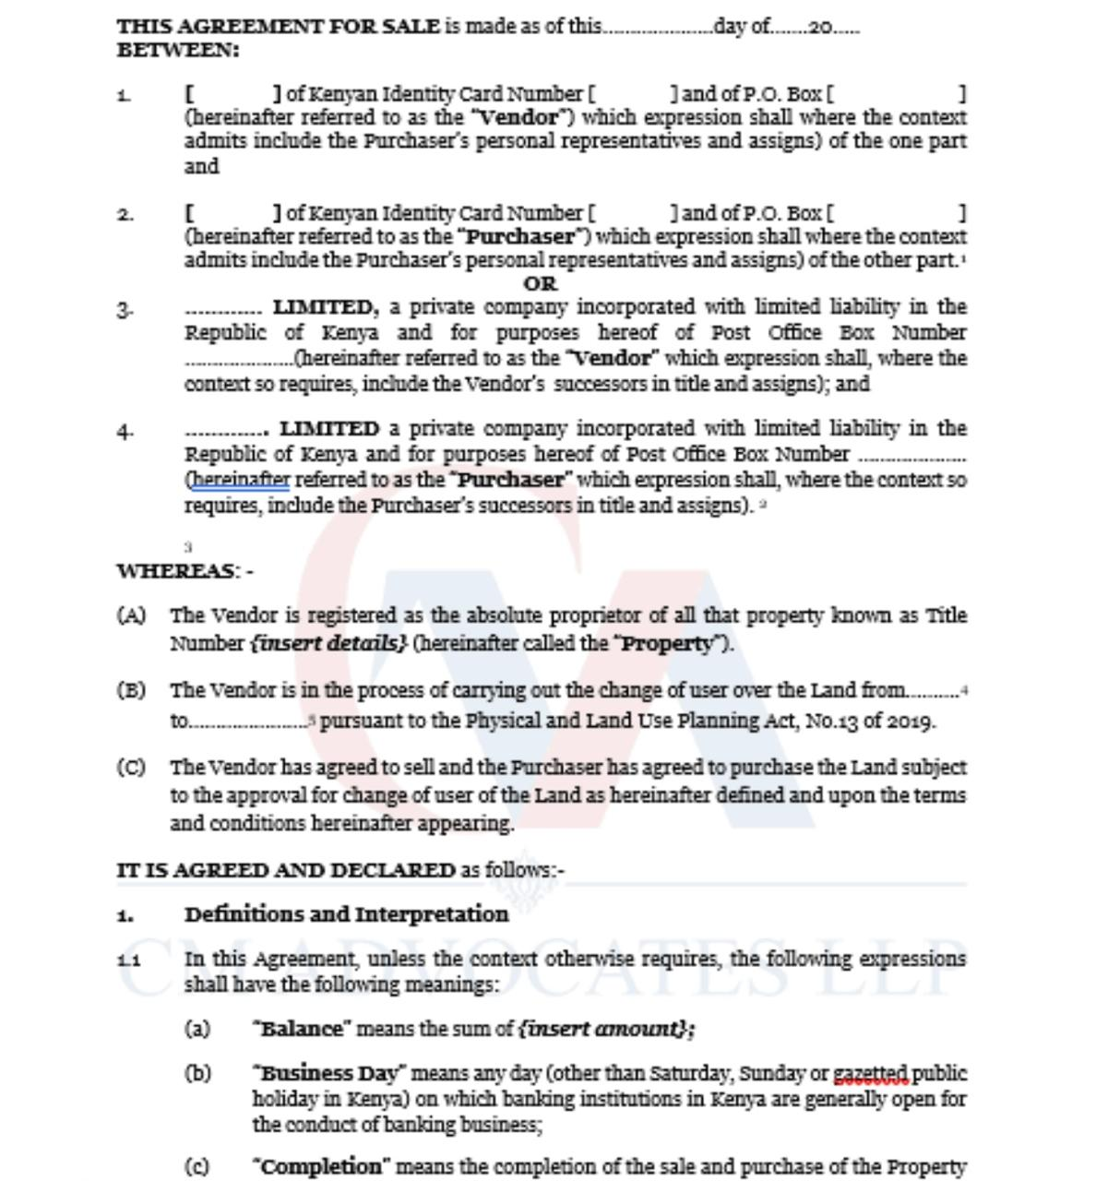

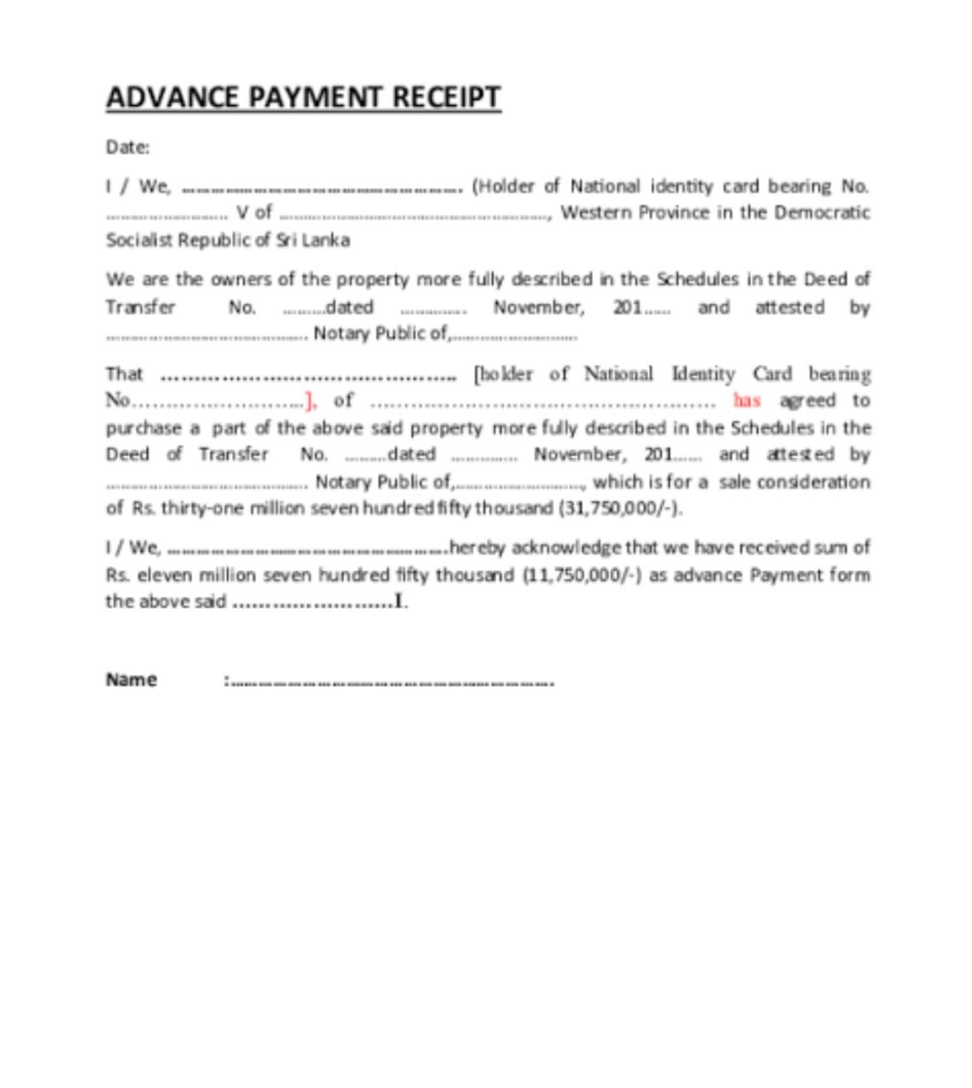

SAMPLE OF A CAVEAT

FORM 26
LAND TITLES ACT
(Section 57)
CAVEAT FORBIDDING REGISTRATION OF DEALING WITH LAND

To: The Registrar of Titles,
Land Registry, Nairobi/Mombasa.

TAKE NOTICE that I, WAMBUGU DAVID KARIUKI of PO BOX 3456-00200 NAIROBI (at which address within Kenya notices may be served), claiming as a creditor in whose favour a debenture has been executed by KUKU YETU holdings creating a floating charge over land in LR No 12230/40 within Langata Constituency, Nairobi County forbid the registration of any dealing with the said land absolutely or unless the transaction be expressed to be subject to the claim of the caveator.
Dated this 23rd August 2024.

I, WAMBUGU DAVID KARIUKI of ID No 42345672 and PO BOX 3456-00200 NAIROBI make oath and affirm that to the best of my knowledge and belief, the claim above referred to is true.
Sworn at NAIROBI.
This 23rd day of August 2024.
Before me,
………MAJIMOTO KAMILI………….
……………ADVOCATE………………..
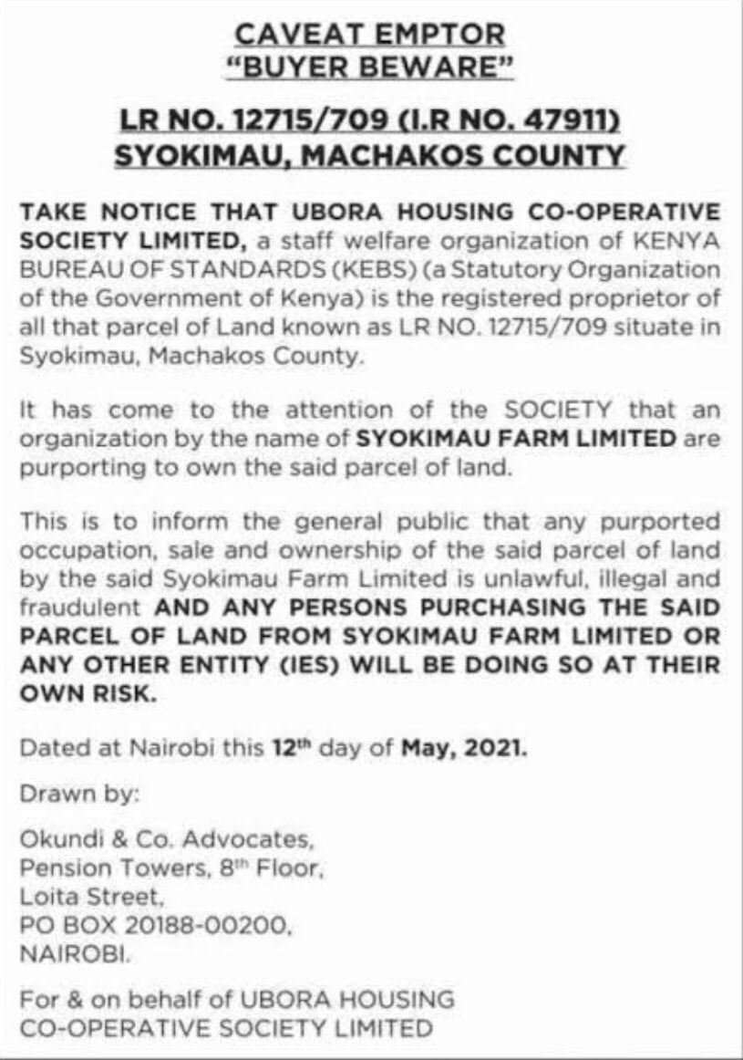

WITHDRAWAL OF CAUTION

Form LRA 69 | (r. 80(4))

REPUBLIC OF KENYA

THE LAND REGISTRATION ACT

THE LAND REGISTRATION (GENERAL) REGULATIONS, 2017

Date Received | Presentation Book | Official Fees Paid
………………… | No…………………. | Kshs.

WITHDRAWAL OF CAUTION

TITLE NUMBER:………………………………………………

Date of Instrument | of
Withdrawal of Caution: |  | 19/05/2023
Date of Caution |  | 18/11/2022
The Cautioner: |  | TOM OELE
The Proprietor: |  | MARY AUMA

The Cautioner HEREBY APPLIES to withdraw the Caution registered in Entry Number(s)
…………………………………….. on the Encumbrances Section of the Register.

EXECUTION

IN WITNESS WHEREOF this withdrawal of caution has been duly executed this..........19th ..............…. day of……MAY………………..2024…..
SIGNED by the Cautioner
presence of:-

TOM OELE
Coloured
Photograph

ID/No…………28374377374……………..
PIN No……………AK734638S.………….
Signature………………TO…….………

Certificate of Verification

I CERTIFY that the above-named …………TOM OELE…………………
appeared before me on the …19th………. day of..…MAY………. 2024….
and being known to me/being identified by*………………………………..

of ………………………… acknowledge the above signatures or marks to be

his/hers and that he/she had freely and voluntarily executed this instrument and understood its contents.

………………………………………..
Signature and Designation of
Person Certifying**

REGISTERED and SEALED this …19TH………. day of …MAY……………. 2024……

LAND REGISTRAR
Seal…………………………………………………..

Name:…KEITH MOKAYA…………………………… Registrar’s Stamp / No………012……

Signature: …………KM………………………………..

WITHDRAWAL OF A CAVEAT

Form LRA 69 | (r. 80(4))

REPUBLIC OF KENYA

THE LAND REGISTRATION ACT

THE LAND REGISTRATION (GENERAL) REGULATIONS, 2017

Date Received | Presentation Book | Official Fees Paid
………………… | No…………………. | Kshs.

WITHDRAWAL OF CAUTION (CAVEAT)

TITLE NUMBER:………………………………………………

Date of Instrument | of
Withdrawal of Caution: |  | 27/04/2024
Date of Caution |  | 16/07/2018
The Cautioner: |  | BINTI MREMBO
The Proprietor: |  | KAKA MREFU

The Cautioner HEREBY APPLIES to withdraw the Caution registered in Entry Number(s)
…………………………………….. on the Encumbrances Section of the Register.

EXECUTION

IN WITNESS WHEREOF this withdrawal of caution has been duly executed this..........27TH ..............…. day of…………APRIL…………..2024…………….

SIGNED by the Cautioner
presence of:-
BINTI MREMBO

Coloured
Photograph

ID/No………124453453……………….
PIN No……………5KJFH858.…………
Signature………………BM…….………

Certificate of Verification

I CERTIFY that the above-named …………BINTI MREMBO…………
appeared before me on the ……27TH…. day of …APRIL………. 2024….
and being known to me/being identified by*………………………..

of ………………………… acknowledge the above signatures or marks to be

his/hers and that he/she had freely and voluntarily executed this instrument and understood its contents.

………………………………………..
Signature and Designation of
Person Certifying**

REGISTERED and SEALED this ………….day of ………………. 20……

LAND REGISTRAR
Seal…………………………………………………..

Name:KEITH MOKAYA…………………………… Registrar’s Stamp / No…012…………

Signature: …………K.M………………………………..

